Project 2B

Thermal Systems

Fall 2018

**Propulsion System of a Drone**

|  |  |
| --- | --- |
| Charlie Nitschelm  University of New Hampshire  Mechanical Engineering | Joseph Williams  University of New Hampshire  Mechanical Engineering |

|  |  |  |
| --- | --- | --- |
|  | Thomas Collins  University of New Hampshire  Engineering Physics |  |

**Abstract**

Through modern advances in technology, drones have become increasingly versatile, with uses ranging from commercial package delivery to military reconnaissance. Drones have become more popular and more feasible then anytime in the past. With the rise in popularity, we were commissioned by Dr. Allard to design a jet-engine propulsion system for a new generation, high performance Unmanned Aerial Vehicles (UAV).  The UAV will carry 100 kg of fuel and 100 kg of equipment needed for its assumed mission. With these initial weights, the plane is calculated to weigh 1,700 kg upon takeoff. The total efficiency of the UAV’s propulsion system, including the compressor, turbine and nozzle, cannot exceed 260%. The actual jet-engine cycle with assumed inefficiencies were compared with the ideal jet-engine cycle to determine the best system to deliver the highest maximum overall efficiency. From our analysis we determined that the optimal efficiencies for the compressor, turbine, and nozzle are 90%, 72%, and 98%, respectively, resulting in an overall cycle efficiency of 52.7%. When we examined the effect of pressure ratio and maximum temperature, as these parameters increase, so do the efficiency and performance of the cycle. With this relationship in mind, we concluded that a pressure ratio of 23 and a maximum combustion temperature of 1,600 resulted in the best cycle with the consideration of what the compressor and combustor could actually handle. Using actual cycle parameters, the heat of formation of our potential jet fuels (Kerosene, Methanol, and Trinitrotoluene), and our calculated drag force, we found the UAV yielded a maximum range of 8,855km when traveling at 39m/s, as any velocity greater than 39m/s contributed to a decrease in range. We also determined that the optimal cruising altitude for the UAV to be at 13,000 meters with a performance of 584 KJ/kg. The exhaust of was also calculated using stoicheometry to determine the effect of this drones use on the environment. Once the cycle efficiencies, cycle parameters, fuel choice and optimal crusing altitude and speed was chosen, a final anlysis on all of these factors can narrow in on the amount of fuel that should be chosen for takeoff to maximize its range while still picking itself off of the ground.

**Component Efficiencies**

 To begin designing a new optimized jet-engine propulsion system, we had to start with optimizing the jet-engine cycle with our assumed parameters. The compressor and turbine cannot exceed 90% efficiency and the nozzle cannot exceed 98%. With a combined limit for efficiency of 260%, we implemented these specifications into our overall efficiency calculator until it resulted in the highest efficiency overall for the cycle. This was completed with the equations relating the ideal to actual specific enthalpys to the actual efficiencies of each device seen below.

(1)

(2)

(3)

With the selected efficiencies to result in the best cycle given our constraints, a temperature vs. specific entropy plot could be graphed to visualize the difference in the cylce when components have inefficiencies compared to the ideal. The compressor, turbine and nozzle efficiencies of 90%, 72%, and 98%, respectively, are illustrated below in Figure 1. The overall efficiency was calculated to be 50.19% with a heat transfer of 885 KJ/kg during the combustor process.

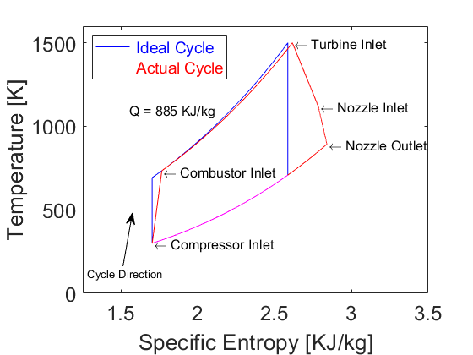

Figure 1 - Ideal and actual cycle of the UAV jet propulstion system

**The Effects of Pressure Ratio and Maximum Temperature**

Furthermore, the next analysis needed to be completed was the desired pressure ratio and maximum temperature for the UAV jet propulsion cycle. The efficiency and performance of the cycle were calculated to allow us to peer into what parameters should be selected to further optimize the propulsion system. The performance of the cycle was calculated by the equation

(4)

(5)

and the efficiency of the cycle was calculated by the equation

where the specific enthalpy values are now for the actual cycle, as the component efficiencies have already been calculated and accounted for in the analysis. Figure 2 illustrates how maximum temperature effects the overall cycle efficiency and performance. As the combustor temperature increases, efficiency increases until it hits 1,600 K, where it begins to drop slowly as the temperature rises to 2,000 K. The performance increase linearly with maximum temperature, yielding a decision to have the maximum combustor temperature to be 1,600 K, with the consideration if this temperature is viable with current material technologies, which it is.

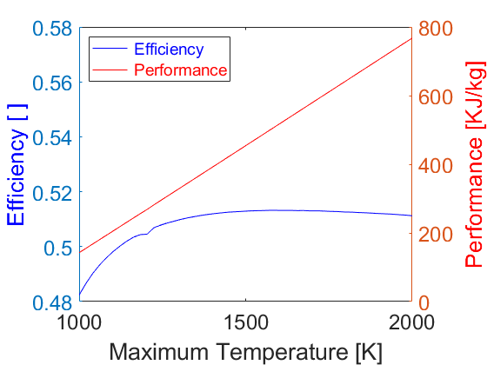

Figure 2 - The efficiency and performance of the jet propulsion cycle as a function of maximum combustor temperature

The last parameter to determine for the cycle is the compressor pressure ratio. Figure 3 illustrates the relationship of this parameter to the cycle efficiency and performance. As pressure ratio increases, the efficiency rises logarithmically converging at an overall ifficency of ~0.6, and the performance peaks at a pressure ratio of 15 and falls slowly as pressure ratio continues to increase. From the graphical representation of the data, we decided that a pressure ratio of 23 is a reasonable pressure ratio to select to compromise between the best performance and best efficiency. The combination of pressure ratio and maximum temperature yielded a final, optimized efficiency and performance of .527 and 450 KJ/kg, respectively. With the maximum combustion temperature and compressor pressure ratio, we can move forward to predict the drone range with its jet propulsion system defined.

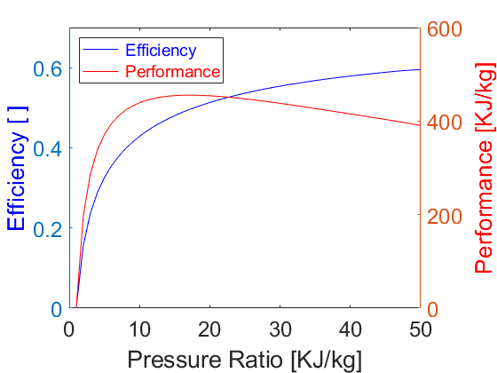

Figure 3 - The efficiency and performance of the jet propulsion cycle as a function of compressor pressure ratio

**Range with Velocity**

To begin our investigation on the range of the UAV, we start with how velocity affects its overall performance. The UAV implements a NACA 0015 airfoil which defines it life and drag with respect to its angle of attack. A constant density of was assumed for simplicity during this analysis. A platform area of was chosen from the infromation we could obtain on its overall shape. A mass of was chosen as these values are close to other drones researched. For the drone to takeoff, its force of lift must be greater then its weight. Using an iterative process calculating the effect of 1 kg of fuel with an initial fuel of 100 kg, we were able to calculate the total range the drone can fly before running out. This was determined by calculating the coefficient of lift, its respective coefficient of drag, and use those values to calculate its distance flown. The equations below illustrate this exact process to iteratively calculate the total range where

(6)

(7)

(8)

(9)

(10)

and .

Initial conditions must be taken into consideration to achieve flight. is the minimum velocity needed to fly neglecting ground effect to optimally pick the drone off the ground by creating enough life to overpower its weight. Velocities greater than were neglected as its trend from the graph maes those speeds not efficient compared to the lower speeds. An optimal cruising speed of was determined to achieve a maximum range of 8,754 km.

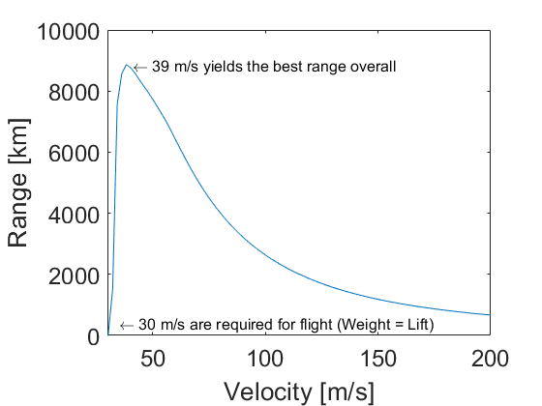

Figure 4 - The range and velocity of the UAV using Kerosene as the working fuel

**Range with Fuels**

We chose to investigate Jet Fuel (A-1, Kerosene), Methanol, and Trinitrotoluene. Kerosene, Methanol, and Trinitrotoluene have chemical formulas of C12H26, CH4, and C7H5N3O6 , respectively.  Kerosene is used globally in turbine engines (jet engines and turboprops), specifically those used in civil aviation [1]. Methanol is less expensive compared to ethanol and petroleum-based fuels. Methanol is produced sustainably and has a low overall carbon footprint [2]. Trinitrotoluene was picked for our analysis due to its highly exothermic properties [3]. TNT is not a viable option, but it was selected as a relation between different types of fuels and their energy potential as many know

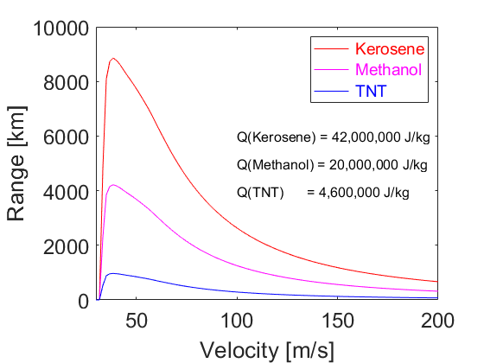

Figure 5 - The range and velocity of the UAV with different working fuels

From Figure 4, kerosene functions with the most efficiency, delivering a higher range then the other fuels tested. This matches with industry standard as jet fuel was made precisely for this application. Methanol had the second highest and Trinitrotoluene had the lowest efficiency with respect to its achieveable theoretical range.

|  |  |  |  |
| --- | --- | --- | --- |
|  | Kerosene | Methanol | Trinitrotoluene |
| QCombustion  (J/kg) | 42,000,000 | 20,000,000 | 4,600,000 |

Table 1 – Different heat of formations for various potential UAV jet propulsion fuels

The values in Table 1 were calculated with the following method:

1. Pick a fuel for a combustion process and then

balance the stoichiometric equation 

1. Solve the thermodynamic first law and determine Qcombustion for each kilogram of fuel combusted
2. Use equation 10 to determine Q with the overall cycle efficiency calculated previously

Next, we took experimentally determined values to analyze the CO2emission of the selected fuels. Kerosene has a CO2emission of ethanols CO2 emission is about 66% that of Kerosene with around Lastly, starting from TNT’s stoichiometric balanced equation we see that it has no CO2emission. On the other hand, TNT produces CO which is more harmful to the environment than CO2.

**Range with Altitude**

The range and performance of the drone was evaluated as a function of altitude to determine the best height the UAV should fly at to move efficiently, and more importantly, fly further. Selecting our cylce parameters already analyzed for most efficient results, we calculated a change of performance and range with increasing altitude from sea level.

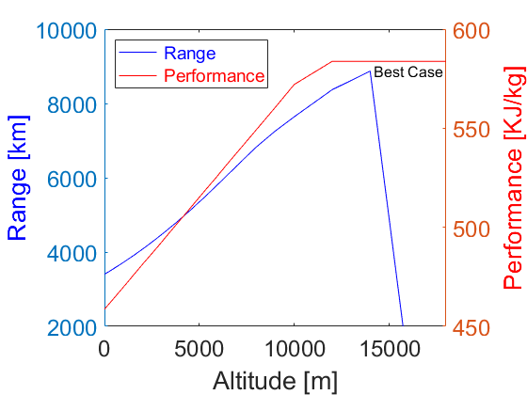

Figure 6 - The range of the UAV at various altitudes with constant velocity

As seen in Figure 5, both the range and the performance tend to increase with altitude until about 13,000m. The range increases with a linear rate from see level until 13,000m, then suddenly drops as the cycle becomes inefficient due to the low pressure and density of oxygen available. The performance analysis leads us to believe that once you reach an altitude of around 13,000m you reach a plateau in both overall performance and range. Our final altitude recommendation would be to fly the UAV at a maximum altitude of 13,000 meters to ensure that you utilize the most efficient density of air but being cautious to not go higher with the risk of low range approximations.

**The Affect of Various Fuel Tanks on Range and Performance**

The first assumption we made when calcuating range was the intial amount of fuel the UAV could hold upon liftoff. To recondier this assumption, we would like to definitivly decide what amount of fuel the drone can hold to achieve the greatest range and keep optimal performance. Figure 7 below details that as fuel mass increases, range increases nearly linearly. One affect this will have is the speed required to pick the plane up upon takeoff due to the increase in initial weight from the working fuel. With an intial fuel mass of 300 kilograms, the range the UAV is capable of traveling increases by nearly a factor of 3 with respect to the of fuel assumed previously. It is slightly smaller then an exact factor of three due to an increase in mass, yielding a less efficient path to maintain constant altitude. 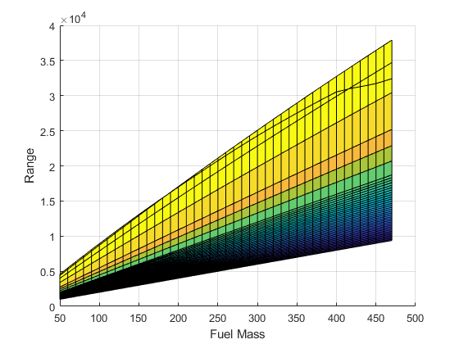

Figure - A Two-Dimensional version of a Three-Dimensional plot to emphasize the effect of fuel mass on overall range

Figure 8 illustrates the relationship of fuel mass, range and performance in a three-dimensional graph. It provided us with the verification that as fuel mass increases, the range increases as from before, but the overall performance decreases slighly as it is pushing harder to propel more weight through the atmosphere as it travels the range it can before running out of fuel. From these graphs, we conclude that the more fuel the drone is capable of holding, it should take. If takeoff distance is a constraint, then further analysis would be needed to verify if the drone can reach a velocity to create the force of life to become greater then its weight.

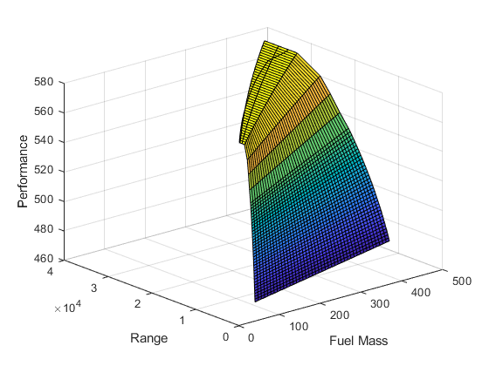

Figure - A Three-Dimensional plot to describe the effect of fuel mass on overall range and propulsion performance

**Final Recommendations and Suggestions**

The final design for our drone was determined by selecting an optimized cycle for performance and efficiency in a jet propulsion system. Through varying parameters and component efficiencies we identified ideal specifications for pressure ratio, turbine temperature, fuel, cruising altitude, and cruising speed. With these specifications we achieved a maximum range and performance. Through an analysis of effects of pressure ratio and maximum temperature we concluded a pressure ratio of 23 and a maximum temperature of 1600K. Following the pressure ratio and maximum temperature, a computational analysis of cruising speed and range was performed. This was then cross referenced with experimentally determined values to ensure an accurate recommendation. We recommend a cruising speed of to achieve an optimal range of 8,754 km. Next, we also evaluated three types of possible fuels to be used on our drone. Taking both environmental and performance considerations into effect we detemined that the best fuel is Jet Fuel (A-1 Kerosene). Kerosene is observed to have a high enthalpy of combustion while remaining low in CO2 emissions. The final recommendation of altitude is chosen to maximize upon the advantages of flying at a higher altitude while considering the negative effects on the performance and cycle efficiency at those respective heights. Through this balancing we determined that flying at 13,000m is optimal for our drone. Lastly, the most fuel that can be stored inside the drone given its limitations should be maximized until the takeoff speed increases over the amount you can achieve given the runway. Further analysis is needed to prepare a data table on what speed you can achieve to determine the maximum amount of fuel you can put on the UAV to takeoff without complications.

**References**

1. “Locations,” Aviation Fuels | Glossary | Mabanaft, 27 Nov-2018. [Online]. Available: [https://www.mabanaft.com/en/news-info/glossary/details/term/aviation-fuels.html](https://l.facebook.com/l.php?u=https%3A%2F%2Fwww.mabanaft.com%2Fen%2Fnews-info%2Fglossary%2Fdetails%2Fterm%2Faviation-fuels.html%3Ffbclid%3DIwAR07f96MhZiAIe7ZFz0dKMMcxHi46aHtXKQ6r-u2DZm_ttudgM8dJX-JxrU&h=AT25SOTypdG0QtA7hyMD-AMjPETPFdbVQfXGK3y-J7NysfEvoid1WakTqoh936nMxLP6Eze4SC_wAF76_ZYd6VnV1qkGCoFbq0Nm45wR9yDhVLjxhUMC4KEnbWRa9k-Xv0p8ig). [Accessed: 05-Dec-2018].

2. “Aviation fuel,” Wikipedia, 27-Nov-2018. [Online]. Available: [https://en.wikipedia.org/wiki/Aviation_fuel](https://en.wikipedia.org/wiki/Aviation_fuel?fbclid=IwAR26nZS8edSeN8EUb_6Tqj2BstTBA1nPh8znHmjH30mYgx9wDoPGwW_cmfk). [Accessed: 05-Dec-2018].

3. “Combustion of Fuels - Carbon Dioxide Emission,” *Engineering Toolbox*. [Online]. Available: https://www.engineeringtoolbox.com/co2-emission-fuels-d_1085.html. [Accessed: 05-Dec-2018]. 

**Appendix**

**Percent Contributions**

Charlie Nitschelm – 33.3 %

*Wrote for Kevin Johnson*

*Electronic Signature*

Joseph Williams – 33.3 %

*Wrote for Zachary Shelby*

*Electronic Signatur*

Thomas Collins – 33.3 %

*Wrote for Jonathan Stahl*

*Electronic Signature*